**Poultry Farming:**

Three types of poultry farming’s are there.

* Egg Business(Layer)
* Hen Business(Broiler)
* Integration

1. **Egg Business:**

* It is time taking business for instance 18 months to farm.
* Business investments are high ( Approx. 30 Lacks ).
* Successful business.

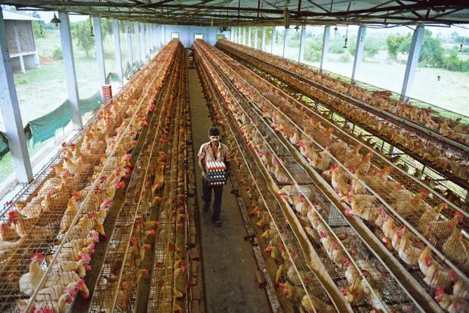

**2.Broiler’s farming:**

* Easy to maintain.
* Duration time is less, minimum 45 days and maximum 50 days.
* Within the duration period we need to do a 3 vaccinations to the hen.
* We can do 6 batches per year.

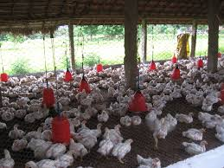

**Chicks:**

* Chick cost is 18 to 20 rupees.
* We can buy chicks in Chittoor district only (exact place i don’t know).

**Vaccination:**

* 1st vaccination in between 5th day to 7th day we should give **“B1”** medicine.
* 2nd vaccination in between 11th day to 14th day we should give "**Gumboro”.**
* 3rd vaccination in between 20th day to 24th day we should give **“Lasota”.**
* vaccination is very cheap, for three term medicines costs around 3 rupees (per chick).

**Feeding:**

* So many brands of feeds are available in market.
* Feed cost is little bit expensive per kg it costs 28 to 30 rupees.
* Present market Sneha, Vimal, Henrich, Bhavani brands feeds are available.

**Final step:**

* With In 40 days chicken should gain weight more than 2 kgs.
* Stock should not maintain more than 50 days in shed because It increases maintenance.
* After the clearance of last batch, shed should be cleaned and restart the new batch.

**Challenges:**

* You need patience.
* Marketing is the main challenge.
* we need to check each and every hen daily.
* We should bare the smell ☺.

**Advantages:**

* We can maintain the poultry in normal water (except salt water).
* Yearly we have 5 to 6 batches in hand so that we can recover any of the batch loss.
* Demand is same irrespective of season.

**Disadvantages:**

* Should be care at diseases (for hens ☺).
* Should maintain temperature at 25 to 40 degrees.

**Conclusion:**

If you maintain it perfectly, profit is in between 30 to 40 rupees per chicken (excluding your investment on one chicken).

**3.Integration:**

In this process we need not to bother of things like buying the chicks and feeding. Companies will take care of it, only thing we can do is maintain them safely and give it back to companies with growth.

**In this case we don’t have any loss, will get minimum profit.**